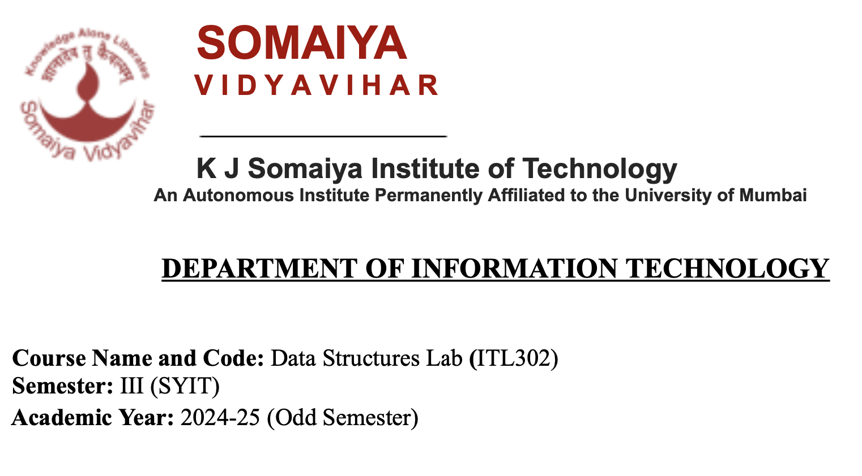

**Experiment No:7**

**Aim**: Implementation of any one Graph Traversal Technique for real-world application.

**Code:**

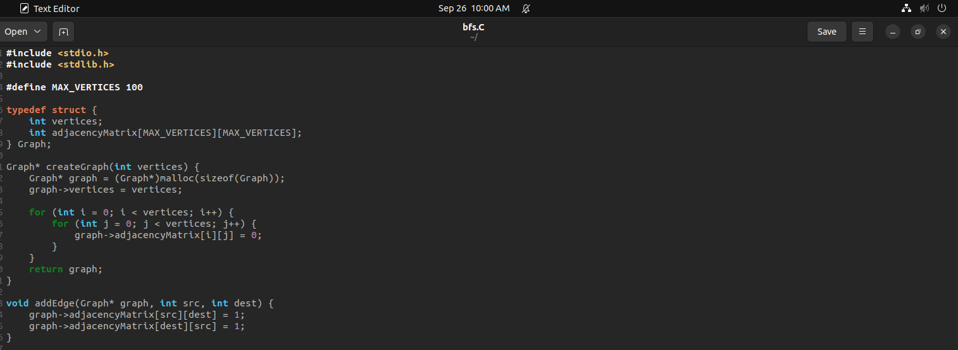

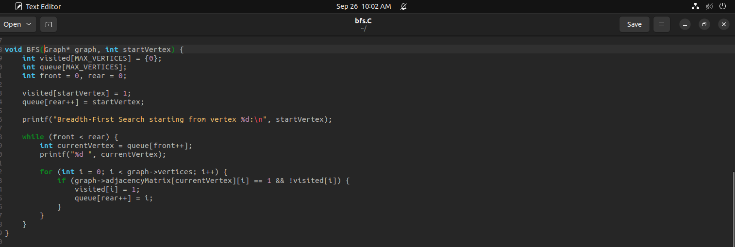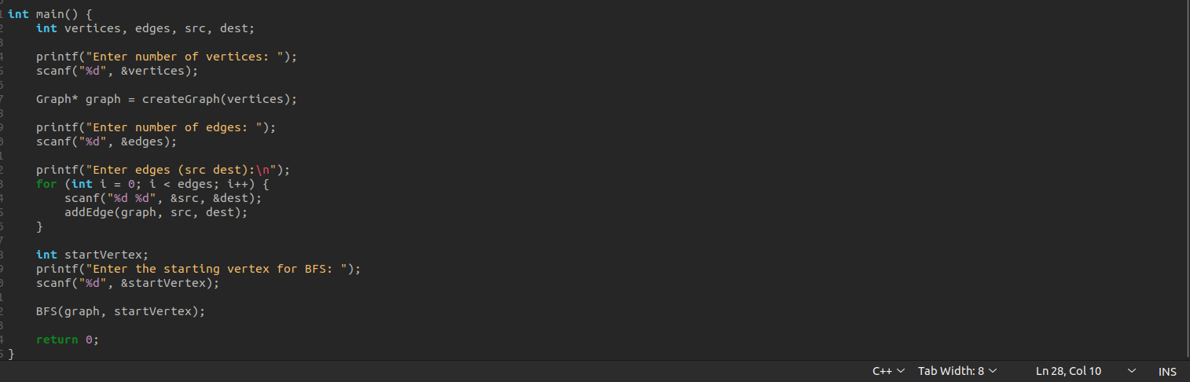

**Output:**

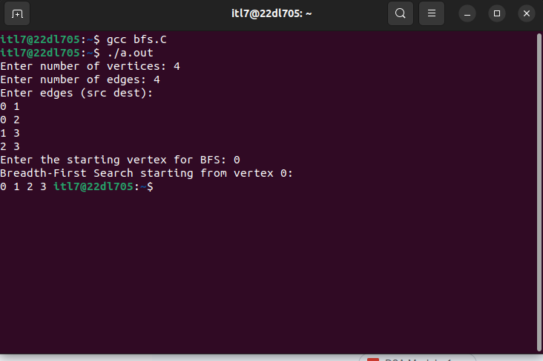

**Submitter Details -  
Name of Student: Yash.M.Dharamshi**

**Roll No.: 22  
Date of Performance: 27/09/2024**

**Date of Submission: 27/09/2024**